1.Write an assembly language program for adding two 8-bit data using 8085 processor.

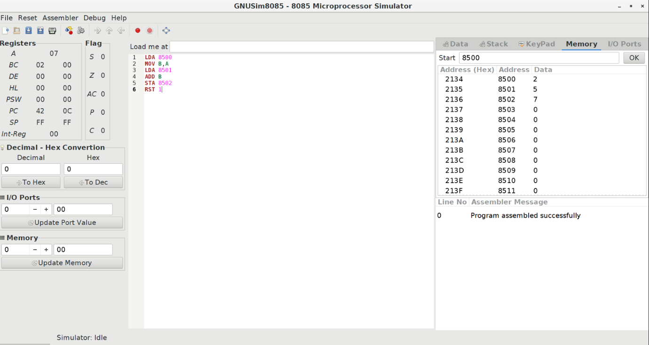

2.Write an assembly language program for subtraction of two 8-bit data using 8085 processor.

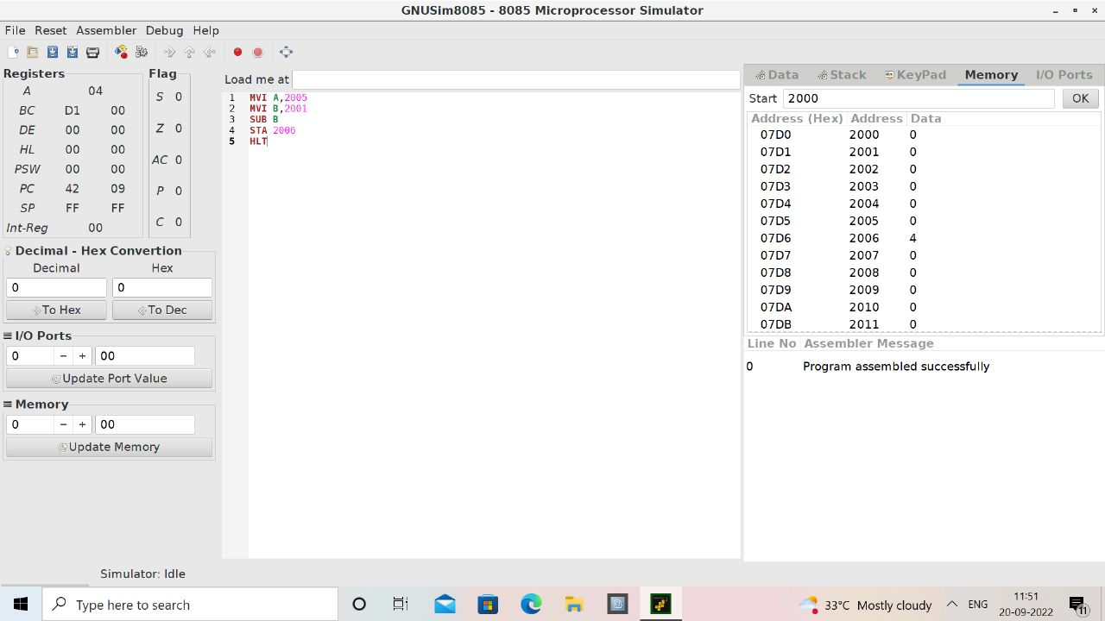

1. Write an assembly language program for adding two 16-bit datausing 8086 processor.

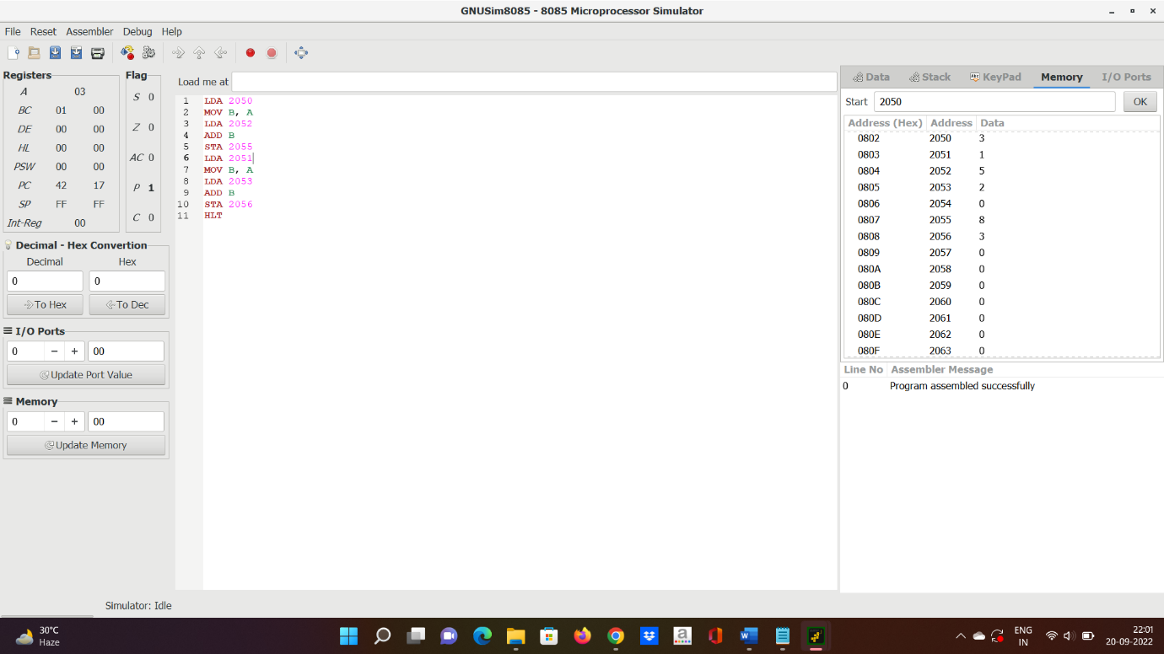

4.Write an assembly language program for subtracting two 16-bit datausing 8086 processor.

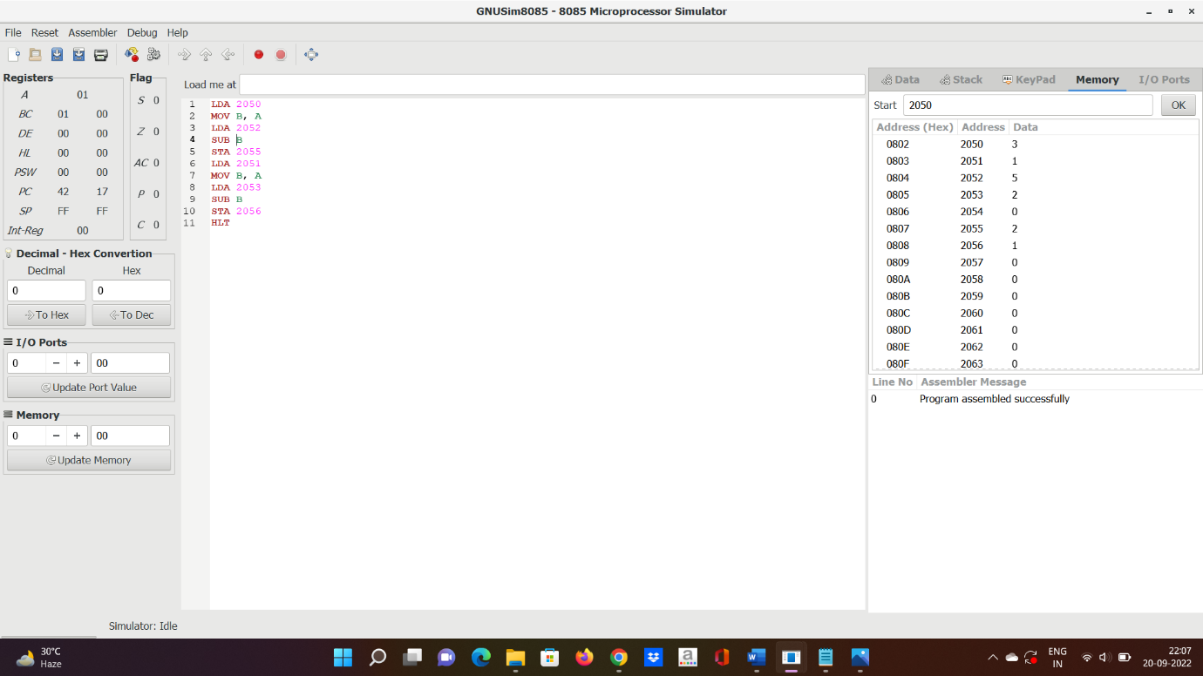

**5.**Write an assembly language program for multiplication of two 8-bit using 8085 processor.

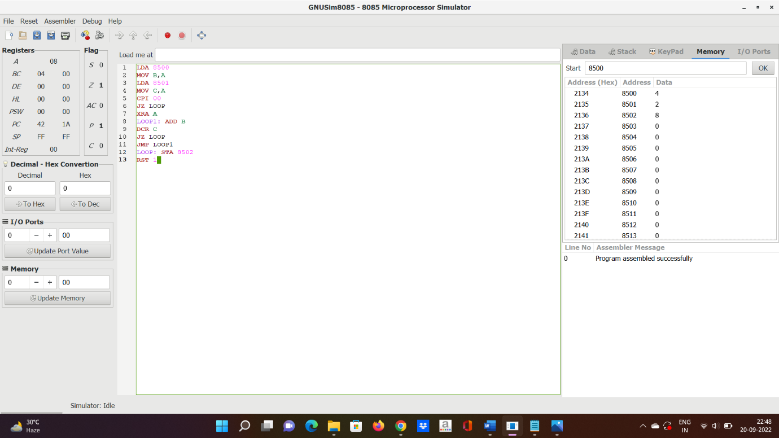

**7.**Write an assembly language program for multiplying two 16-bit datausing 8086 processor

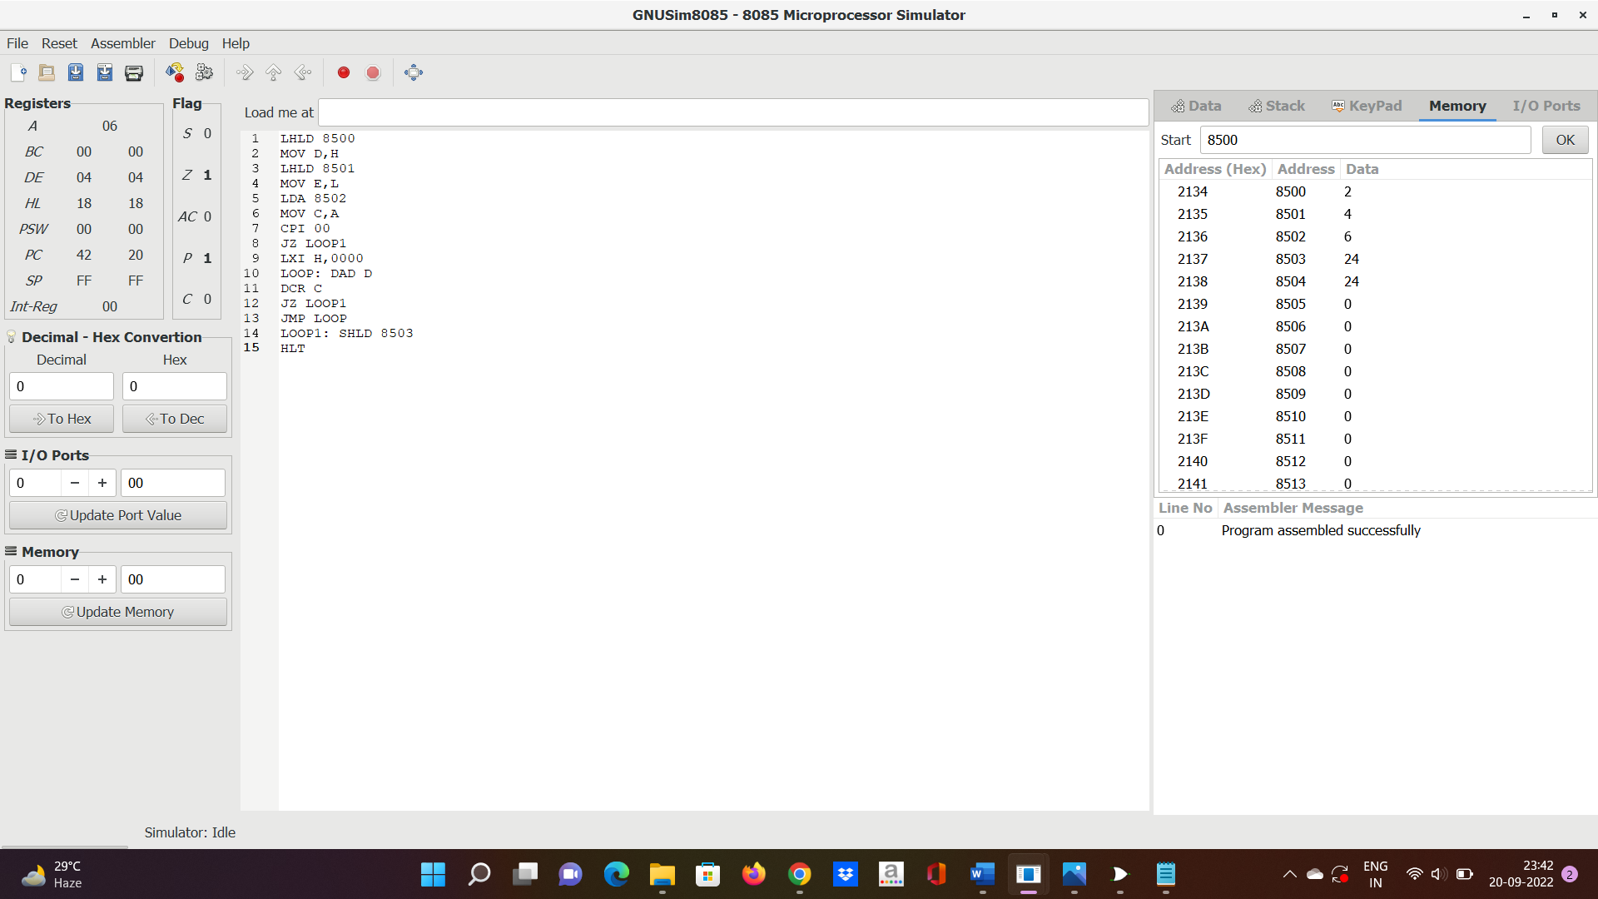

6. Write an assembly language program for division of two 8-bit data using 8085 processor.



8.Write an assembly language program for dividing two 16-bit datausing 8086 processor.

